** P.E.S COLLEGE OF ENGINEERING, MANDYA**

**(An Autonomous Institute under Visvesvaraya Technological University, Belagavi)**

**

A DISSERTATION REPORT ON

**“CALCULATION OF RETINAL BLOOD VESSELS TORTOUSITY”**

Submitted in partial fulfilment of the requirement

For the award of the

**BACHELOR OF ENGINEERING DEGREE**

**Submitted by**

**NAGARATNA GUDLANOOR [4PS15EC059]**

**NAGESH KUMAR [4PS15EC060]**

**NANDI VISHAL U [4PS15EC061]**

**PRAGATHI N [4PS15EC071]**

**Under the guidance of**

**Mrs.NISCHITHA K**

**( Assistant Professor)**



**Department of Electronics and Communication Engineering**

**P.E.S.College of Engineering, Mandya.**

**2018-2019**

****P.E.S COLLEGE OF ENGINEERING**

**MANDYA-571401**

**(An Autonomous Institution Affiliated to VTU, Belagavi)**

**DEPARTMENT OF ELECTRONICS AND COMMUNICATION**

**ENGINEERING**

**CERTIFICATE**

This is to certify that,

Nagaratna Gudlanoor [4PS15EC059]

Nagesh Kumar L [4PS15EC060]

Nandi Vishal U [4PS12EC061]

Pragathi N [4PS12EC071]

have successfully completed the project work entitled **“CALCULATION OF RETINAL BLOOD VESSELS TORTUOSITY”** in partial fulfillment for the award of degree of **Bachelor of Engineering in Electronics and communication Engineering** of **P.E.S college of Engineering, Mandya, VTU Belagavi** during the year **2018-2019**. It is certified that all corrections/suggestions indicated in internal assessment have been incorporated in the report deposited in the Library. The project has been approved as it satisfies the academic requirements in respect of project work prescribed for the degree **in Bachelor of Engineering.**

_________________________ _________________________

Signature of the guide Signature of the HOD

**Mrs. NISCHITHA.K**  **Dr.K.RADHAKRISHNA RAO** Assistant Professor Professor & HOD

**____________________________**

**Dr. H. V. Ravindra**

Principal

PES College of engineering, Mandya

|  |  |  |  |
| --- | --- | --- | --- |
| Project work viva-voice examination | | | |
| Sl.No | Examiners | | Date |
| Name | Signature |
| *border*1 | *border* |  |  |
| 2 |  |  |  |

**P.E.S COLLEGE OF ENGINEERING**

(An Autonomous Institute under VTU, Belagavi)

MANDYA – 571401

**Department of Electronics and Communication Engineering**



**DECLARATION**

We **Nagaratna Gudlanoor , Nagesh Kumar L , Nandi Vishal L , Pragathi N** students of 8th semester Bachelor of Engineering in Electronics & Communication, PESCE, Mandya, hereby declare that the project work being presented in the dissertation entitled **“CALCULATION OF RETINAL BLOOD VESSELS TORTOUSITY”** is an authentic record of the work that has been independently carried out by us and submitted in partial fulfilment of the requirements for the award of degree in semester **Bachelor of Engineering in Electronics & Communication,** affiliated to **Visvesvaraya Technological University (VTU), Belagavi** during the year 2018-2019.

The work contained in the thesis has not been submitted in part or full to any other university or institution or professional body for the award of any other degree or any fellowship.

Place: Mandya

Date:

Nagaratna Gudlanoor

Nagesh Kumar L

Nandhi Vishal U

Pragathi N

**ACKNOWLDEGMENT**

It is with great satisfaction and euphoria that we are submitting this report on project work that we have successfully completed as required by the curriculum.

We wish to express our deep sense of gratitude to our project guide **Mrs.Nischitha K,** Assistant Professor of E&C Engineering ,for his ample guidance and useful suggestions throughout our project work and we are thankful for his time and effort and also for his continued encouragement in preparing this report.

We would like to convey our heart full thanks to our Head of the Depatment of Electronics and Communication Engineering ,**Dr. K.A.Radhakrishna Rao** ,for being there in monitoring us throughout our project work.

We take this immense pleasure in thanking ,our beloved Principal **Dr.H.V.Ravindra ,** P.E.S

College of Engineering , Mandya , who has always been a great source of inspiration and has encouraged us all through.

We thank all the teaching and non-teaching staff of our department for being a source of information in many aspects in completing this endeavour.

We would like to express our deep sense of thankfulness to the communications technology that helped us in finding all the information required to complete this work and credits to the scientists and engineers behind the technologies.

We thank one and all who have helped us directly or in- directly in completing our project work.

NAGARATNA GUDLANOOR (4PS15EC059)

NAGESH KUMAR L (4PS15EC060)

NANDHI VISHAL U (4PS15EC061)

PRAGATHI N (4PS15EC071**)**

**ABSTRACT**

Tortuosity and retina blood vessel dilation are important symptoms of plus disease in retinopathy of prematurity. The analysis of retinal blood vessel plays an important role in detecting and treating retinal diseases .In this project, we use a set of algorithms for the classification and calculation of retinal blood vessels parameters and calculation of tortuosity extracted retinal blood vessels.

**CONTENTS**

**LIST OF FIGURES**

**CHAPTER 1**

**INTRODUCTION**

**1.1 Introduction.**

### Vision is the most fundamental of human senses .The eye is a very comlex and truly amazing organ .It is approximately one inch wide and deep and 0.9 inches tall . Human eyes allow humans to appreciate all the beauty of the world they live in ,to read and gain knowledge,and to communicate their thoughts and desires to each other through visual expression and visual arts.The human is wrapped into three layers :the external layer,formed by the sclera and cornea;the intermediate layer,divided into two parts: anterior (iris and culinary body) and posterior (choroid );and the internal layer,or sensory part of the eye,the retina.

### Cornea : Light starts its journey into the eye by passing through the cornea. This layer of transparent tissue sits on top of the iris and pupil. It helps to focus light to produce a clear image on the retina, and acts as an additional protective layer for the eye.Although the cornea looks curved, it is usually actually a flat sheet of uniform thickness.

### Pupil : The pupil is the opening to the inner chamber of the eye. Pupils appear black because light passes through them and does not return. The pupil, then, is our actual “window to the world.”Once it has passed through the pupil, light is focused by the lens. It then travels through the rest of the eyeball to the retina, which lies at the back of the eye. The retina turns the light into signals our brain can understand.

### Iris : The iris is the colored ring around the pupil. Different people have different amounts of pigment in their iris, resulting in eye colors ranging from blacks to very pale blues and greens.

### Lens: The lens of the eye lies immediately behind the pupil. Some people think that the lens of the eye is found on the outside, where the cornea is – perhaps because of the use of the word “contact lenses.” But the lens that performs the final focusing of light is found inside the eye, behind the pupil.

The lens is a complex structure. It is made of an elastic capsule containing proteins and water, which refract light at a constant rate just like the lenses used in glasses. It has layers of soft tissue surrounding a firm “nucleus.”

### Retina : The retina is a light-sensitive layer of tissue that covers the back of the inner eyeball. It contains light-sensitive cells which can determine light, dark, and color to assemble images of the world. The retina then converts that color information into neural information and sends it to the brain for processing.

### Optic Nerve : The optic nerve is a bundle of neural fibers that travel from the retina to the brain. Each optic nerve encodes the image data recorded by the retina in the form of neural signals that can be read by the brain.

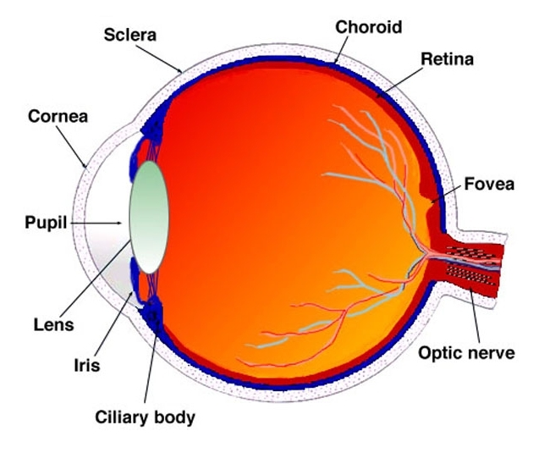

Fig 1.1 Human Eye.

Fundus photography documents the retina, the neurosensory tissue in our eyes which translates the optical images we see into the electrical impulses our brain understands. The retina can be photographed directly as the pupil is used as both an entrance and exit for the fundus camera's illuminating and imaging light rays. The patient sits at the fundus camera with their chin in a chin rest and their forehead against the bar. An ophthalmic photographer focuses and aligns the fundus camera. 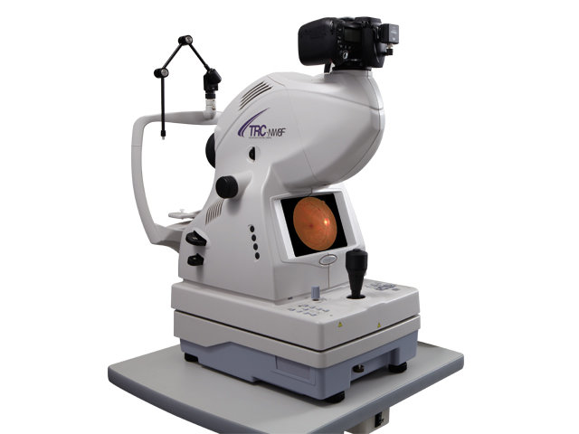

Fig 1.2 Fundus camera.

Recent clinical survey shows a number of premature infants being diagnosed with Retinopathy of Prematurity (ROP) a retinal disorder due to abnormal growth of blood vessels. It is also called as RetroLental Fibroplasia (RLF). This disease is mainly seen in premature born babies having received intensive neonatal care, in which oxygen therapy is used on them due to the premature development of their lungs. This consequent threat of blindness can be cured with early screening or can be diagnosed by dilation and tortuosity of blood vessels. We use many of the algorithms and methods like Morphological and linear filtering, Vessel tracking algorithms, based on Arc Length over Chord Length Ratio. Recent approaches like called the template disk method, mean curvature along condensed phase interfaces in two or three dimensions, estimation of the curvature along a condensed phase interface, are introduced to detect Retinopathy of Prematurity(ROP).

Retina is a layer which is found at the back side of the eye ball which plays main role for visualization. Any disease in the retina leads to severe problems. Blood vessels segmentation and classification of retinal vessels into arteries and veins is an essential thing for detection of various diseases like retinopathy of prematurity etc. This paper discusses about various existing methodologies which are helpful for the detection of tortuosity in retinal fundus image. One of the symptoms of Retinopathy of prematurity causes dialation and twistedness of the blood vessels. Retinal fundus images are available on the publically available Database like DRIVE.

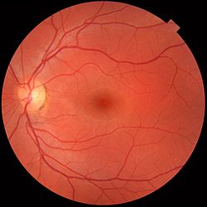

Fig 1.3 Fundus Image

**1.2 Scope Of The Project**

The aim of the project is to calculate the retinal blood tortousity using algorithms for the classification and calculation of retinal blood vessels parameters and calculation of tortuosity extracted retinal blood vessels.

**1.3 Organization of This Project.**

Chapter 1: Here structure of human eye ,introduction about the fundus images are covered and the scope of this project also discussed.

Chapter 2: A brief discussion about the literature survey .

Chapter 3: It involves the current methodologies proposed by different authors.

Chapter 4:It contains the introduction about the..

Chapter 5; It includes the proposed algorithm and implementation .

Chapter 6:It contains the result and the conclusion of our project.

Chapter 7: Future work of our project is discussed.

**Chapter 2**

**Literature survey.**

[1] S. Chaudhuri , S. Chatterjee , N. Katz, M. Nelson, and M. Goldbaum. “Detection of

blood vessels in retinal images using two-dimensional matched filters”. IEEE year 1989.

In this paper, the concept of matched filter detection of signals is used to detect piecewise linear segments of blood vessels in these images. 12 different templates are constructed that are used to search vessel segments along all possible directions. Template matching algorithm offers the advantage of ease of implementation on specialized high speed hardware as well as the possibility for parallel computations. Unlike edge detection algorithm,this method extracts blood vessels as a whole. Matced filter detection method is applicable only to stationary processes. Usually a preprocessing step is performed in which the local mean is substracted from the image and then the pixel intensities are divided by square root of local variance to approximate image as a stationary process.

[2] Chanjira Sinthanayothin, Pattheera Panitsuk, Bunyarit Uyyanonvara National Electronics and computer Technology Center, National Science and Technology Development Agency (NSTDA ”Automatic Retinal Vessel Tortuosity Measurement”.

This paper proposes a method of how to measure and define tortuous scale using the mean curvature. The tortuosity measurement is calculated based on the radius derived from chord in each curve of the blood vessel. The result obtains from this method can set the standard of tortuosity grading in the retinal vessel. The advantage of this method is to reduce the error in tortuosity calculation, which cause by the low quality image of the retinal vessel. In this paper an alternative algorithm for retinal vessel tortuosity calculation with the input of retinal skeleton and this method can be implemented and use as an automated tortuosity calculating system. The result of the calculation will be in range of 0 and 1 by 0 is less tortuous than 1. From the result, we can classify the image tortuosity into at least two groups, tortuous and non-tortuous

[3] S. A. Jameel , Dr. A. R. Mohamed Shanavas2 1Assistant Professor, 2Associate Professor Department of Computer Science Jamal Mohamed College (Autonomous) Tiruchirappalli”

Retinal Vessel Segmentation for Vessel Tortuosity”

Retinal Vessel Tortuosity is useful for (Retinopathy for Prematurity) ROP. Quite a few algorithms for retinal vessel segmentation for vessel tortuosity have been proposed. We propose retinal vessel tortuosity using enhanced chain code algorithm. Retinal Vessel Segmentation algorithms for tortuosity using wavelet analysis, vessel partitioning using branching and ending point, method to measure tortuosity vessel-segment’s edge, improved branching and ending point detection technique, novel mask filter. We attempt to propose retinal vessel tortuosity using enhanced chain code algorithm. This algorithm could be effective one with great correctness.

[4] Anchal Sharma, Shaveta Rani “An Automatic Segmentation & Detection of Blood Vessels and Optic Disc in Retinal Images”

In this paper, preprocessing using neutrosophy presented as the first step in proposed method that used for extraction of blood, which gets better results. Analysis of retinal images is an important aspect for the diagnosis of eye diseases. Conceptual Segmentation is a critical technique in medical imaging. The Processes of identification and division of optic circle and veins are the fundamental strides for the analysis of a few infections that causes visual deficiency like diabetic retinopathy, hypertension, glaucoma and different visual deficiency ailment. These diseases lead to loss of vision. The vein data is required or used to ascertain a roughly position of the optic circle.

[5] R Manjunatha, Mahesh Koti and Dr.H.S.Sheshadri P.E.S. College of Engineering, Mandya  
“Boundary Extraction and Tortuosity Calculation in Retinal Fundus Images”.

This paper presents differential geometrical method for tortuosity measurement. The problem of tortuosity evaluation is formulated as one dimensional differential geometrical curvature characterization. Tortuosity and retina blood vessel dilation are important symptom of plus disease in retinopathy of prematurity. The vessel network extracted from retinal image is subjected to boundary extraction and individual vessel boundaries are extracted as planar curves, further these curves are segmented and differential curvature is computed at segment level and at vessel level for the individual vessels. Vessels with considerable tortuosity are found to be having significant curvature variation compared to the normal vessels. The method is tested and validated on the available public data and local data set.

Chapter 3

Current methodologies

1. **Pre-processing:**

At this stage images of patients’ retinas are acquired or retrieved from sources such as image databases. These images are then pre-processed through operations such as enhancement or smoothing.The set-up of the cameras, in addition to the quality of the captured images

and the outcome of the pre-processing, play a signiﬁcant role in the success

of subsequent stages. The quality of retinal images, has been considered as

one of the problems in successfully capturing images of the ocular fundus

because of factors such as defocus, medial opacities or the presence of artefact

[56, 60]. The preprocessing stage therefore also includes image restoration, in

which damages caused by the image capturing process, noise or blurriness are

reversed. we use some of the gray scale techniques to enhance the contrast of the image using adaptive histogram equalization. In this we use some of the local based drives as input and these are converted into gray scale images to enhance the contrast of the picture or the image of the retina.

1. **Binary image and vascular network:**

We are converting the gray scale image that is obtained into binary image to get the vascular network of the retina. There are diﬀerent segmentation techniques

for diﬀerent tasks. The outcome of this stage is normally a binary image or

a measurement mask with the white colour marking the regions of interests

and black representing the background. Morphological operations can be used

at this stage for further enhancement or correction using operations such as

opening, closing, and dilation or eroding.

1. **Major vessel Extraction:**

In this method we obtain or extract a blood vessel that has two

Dimension curve patches.

1. **Boundary Extraction:**

This process involves the extraction of the boundary of the blood Vessel.

1. **Segmentation and Average Curvature Computation:**

The boundary that is obtained are segmented for the further process and

Calculation of Average Curvature and thus the tortuosity of the blood vessel is calculated.In this stage the segmentation of regions of interests,

which in this case means those regions in the retina that could possibly be

segmented such as the retinal vasculature (retinal arteries and veins) or ab

normal anomalies such as lesions. There are diﬀerent segmentation techniques

for diﬀerent tasks. The outcome of this stage is normally a binary image or

a measurement mask with the white colour marking the regions of interests

and black representing the background. Morphological operations can be used

at this stage for further enhancement or correction using operations such as

opening, closing, and dilation or eroding

METHODS USED BY OTHER AUTHORS.

**Existing tortuosity evaluating features**

This section outlines some of the most used tortuosity evaluating features from the

literature that are based on various approaches to estimating tortuosity in addition

to a number of basic blood vessels structural properties’ measurements. It also

provides a critical evaluation of these features, their strengths and limitations in

order to be incorporated in the proposed tortuosity evaluating framework.

**Distance approach**

These features are mainly constructed to evaluate tortuosity by measuring the length

of the blood vessel segment or curve, or the length of the path that the blood vessel

takes, known as the Arc and denoted by LC; and the length of the straight line

between the two end points of the blood vessel segment or arc, known as the Chord

and denoted by LX. Tortuosity is then estimated mainly by taking the ratio between

those two lengths. The next sections provide some measures based on this approach.

**Relative length variation**

This was the ﬁrst distance based feature. It was introduced ﬁrst by Lotmart

Freiburghaus [63], and altered later by Bracher [7]. This feature subdivides a vessel

segment into a series of single arcs with heights hi, and chord lengths li. Tortuosity

is then estimated as the Relative Length Variation (RLV) 2.2, where L is the length

of the blood vessel, li represents chord lengths and hi is arrow heights. The approxi

mation is derived using a sinusoidal model of a blood vessel segment. Unfortunately,

the technique is not fully automated and it requires manual selection of points on

the fundus photograph to divide the vessel into a series of single arcs. Using this

measure as a part of a suite of tortuosity measures, 91% was achieved in the classi

ﬁcation of segments as tortuous or non-tortuous and 95% in the classiﬁcation of a

whole vascular tree [49] on a private dataset with no particular disease,

RLV =LC/ l ≈8 3n X i=1(hi/li)

**Arc over chord ratio**

The Arc Over Chord ratio (AOC) is the most simple, basic and most used distance

based tortuosity evaluation feature. It is introduced by [48]. Given the blood vessel

segment as a curve o arc (S), and the length of the curve as ( LC), 2.5 or 2.6, and

the straight distance between the two end points of the blood vessel segment, known

as the chord length as (LX) equation 2.7. This feature simply examines how long

the curve is, compared with the straight distance between its two end points. The

feature has zero value for straight vessel segments and increasing positive value for

segments as they become tortuous. It is also free of any manual manipulations or

interactions.



3.1: preprocessing ste[1]Block Diagram.

Pre-precessing: AHE, BI,Vascular Network.

Curvature Computation and tortuosity.

Boundary Extraction &Segmentation.

Vessel Extraction.

Retinal Image.

**Pre-processing:** Here the 8 bit grey scale image GI(x,y) is normalized to get better contrast of the image using AHE (adaptive histogram ) , it is helpful to get the clear vasculature of the retinal fundus image and OD(Optic Disk) then it is subjected to binaries the grey scale image i.e. BI(x,y) to reduce the computational complexity. The detection of OD is favourable for the analysis of retinal image it can serve as a landmark for localizing and segmenting macula (fovea) and vessel structure. The optic disc parameters of premature infants had no correlation with birth weight and gestational age .

Pre problem formulation as presented mostly the prime objective is boundary ex- traction and tortuosity, extraction of vessels requires noise free vascular network to accomplish this, the RI is pre-processed first. However gray scale image can be em- ployed for this, which results in calculation efficiency by eliminating 3-channel processing. All the steps mentioned are carried on 8 bit grey scale image. The grey scale image is pre processed with AHE, BI. The grey scale version of the RI will be effected by the luminous noise of the camera and artefacts due to the relative measurement of the eye’s and camera. To make the grey scale image clear and free of noise AHE is applied. Further to obtain vascular network grey scale image is subjected to binarization.

In current work fundus images from the Fire, Drive and Local data base are used as input. The input image, RI(x,y) is normalized and converted into Gray image, GI(x,y) followed by binarization, BI(x,y). The binarized images, BI(x,y) are subject to the vessel extraction, V(x,y) and characterization for tortuosity Tvn.

## Binary Image and Vascular network:

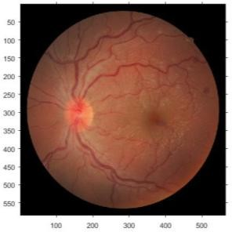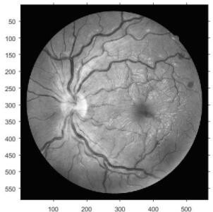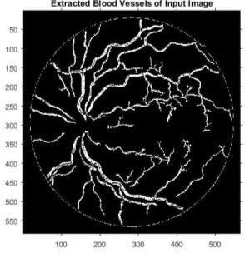

a b c

Figure 2: a) Original Fundus retinal image. b) Normalized grey scale image. c) Vascu- lar network of the binarized retinal image.

The grey scale intensity of the vessels is much prominent compared to the optic disc and retinal background intensity. This makes the vascular network extraction simpler. A vascular network, VN{x,y} is obtained by transforming the pre processed grey scale image into binary image with dynamic threshold level Dth, corresponding to the vessel intensity.

*VN* *x*, *y*  1 *if GI* *x*, *y*  

*Dth* 

(1)

0*else*

 

Dynamic threshold is required as the gray scale intensity of the vessel varies depend- ing on the image contrast. This approach is novel and distinct compared to the tradi- tional thinning algorithms that have been frequently applied in blood vessel extraction [11]. The binary image contains skeleton of vascular network with geometrical infor- mation. Figure 3 shows the histogram information of figure 2b. Figure 2 c shows vascular network for retinal image, where mvn are minor vessels, MVn are major ves- sels and Bpn are bifurcation points.

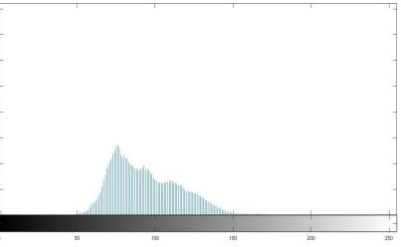

Figure 3: Histogram of grey scale image of figure 2b

|  |  |
| --- | --- |
| VN = | (2) |

* 1. **Major Vessel extraction:** Prime factor of ROP is associated with tortuosity and dilation of major vessels [1, 2].This observation is considered in the current proposed method of tortuosity estimation by processing the vascular network for single major vessel isolation without bifurcation points. Figure 4 shows extracted single major vessels corresponding to the vascular network of Figure 2C. The vessels extracted are two dimensional curve patches with width [Wm] and length [Lm], as shown in Figure

4. Single major vessels are extracted by applying RT (Radon Transformer) [12], Eq.7

No. of major vessels NV

*V*  {*V*1,*V*2 ,*V*3...*Vn*}

(3)

Identify the major vessel length in number of pixels and the corner pixel position.

*V*  {*Vl*1,*Vl* 2 ,*Vl* 3...*V*ln}

*Vc*  {*Vc*1,*Vc* 2 ,*Vc*3...*Vcn* }

(4)

1. **Boundary extraction:** Vessels in binarized retinal image are consid- ered as polynomial functions, . The functions correspond to curves of different shapes, lengths, Vnl and orientations with origin at optic disc.

, (5)

+  +..) (6)

Equation (6) implies that individual vessel boundary can be extracted by masking the image, with angular delta function as

(7)

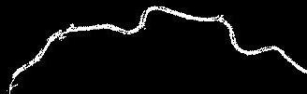Figure 4 shows one extracted single vessel of boundary length LVn as per equation (7). This method of extracting boundaries is treating individual vessels as of single pixel width, this leads to loss of dilation information. Here the vessels are constructed to be continuous curves.

Figure 4: a) Single vessel extracted from the BI, b

) Single vessel traced on the lower edge. c) Vessel traced on both edges. d) Single vessel traced on upper edge .

Boundary extraction of the individual vessel is done on the both edges/ sides (upper

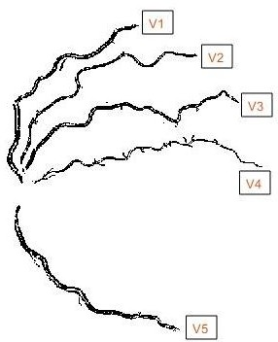and lower). Y

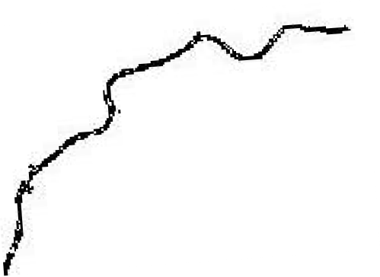

# b)

X

Figure5 a) Major vessels extracted from figure 2C b) Theta calculation plot for the single vessel.

The geometrical pattern of the vessel network is random and this randomness makes boundary extraction challenging due to arbitrary angular orientation of the vessels. As pointed out earlier curvature is computed for the major vessels by consid- ering either of their lateral boundaries. The lateral boundaries B1 and B2 of vessel Vn as shown in Figure 4, are extracted by applying algorithm i.e.

for m=1:length of vessel theta=COS-1(X/hyp) B1(xm,y)= max(VNn(xm,y))

B2(xm,y)= min(VNn(xm,y)) end

By retaining the maximum and minimum Y-co-ordinate pixels at particular X-co- ordinate, this is repeated all along the length of the vessel. The maximum Y-co- ordinate pixels forms a set corresponding to the boundary B1, where as the minimum corresponds to the boundary B2. In order to extract the boundaries in their intact shape, the vessels need to be rotated i.e. to avoid abrupt transitions. Due to make the boundary extraction simpler angular computation is applied to the individual ves- sels.The angle of rotation is found by computing orientation of the vessel with respect to X-axis of Cartesian co-ordinates at its origin, as shown in Figure 5b.

Identify the angle subtended by the major vessels w.r.t the x-axis of the coordinate.

**  [**1,**2 ,**3.....*n* ], (8)

Chapter 6

.

Result

The paper introduces a new geometrically characterized image processing method for the tortuosity detection in ROP cases with simple differential geometrical method for tortuosity measurement, although the method is simple and effective but it considers the vessels to be of single pixel leading to loss of dilation information hence resulting in loss of accuracy. The method can be improvised by updating the model considering curves in two dimensions.

**Current methodlogies.**

296 M.M.G. Macedo, C. Mekkaoui, and M.P. Jackowski

VESSEL TRACKING METHOD.

2 Vessel Tracking Method

The goal of the proposed vessel tracking is to construct a vessel skeleton based

on the extracted centerlines on several slices. CTA and MRA images show vessels

as high intensity proﬁles, with maximum intensity near their centers. The idea

is to model this maximum intensity location as the center of a circle. When the

plane of extraction is completely orthogonal to the vessel, the vessel wall can be

modeled as a circle and this process can be repeated by following the tangent of

the vessel trajectory.

**Statistical Techniques**

For result analysis we also used statistical techniqueslike Mean, Standard deviation, correlation, Pearsonscoefficient of correlation, Product moment correlationcoefficient and Normalization and this statisticaltechniques gives the strong positive correlation and also Normalization gives the similar result like ground truthand proposed algorithm gives the similar outputsaccording to ophthalmologist. This statistical techniqueis one of the most important technique for resultanalysis, Table 3 show the sample images followed byits ground truth of tortuosity verses proposed algorithmtortuosity.

**Conclusion**

There is an urgent need for an accurate robust tortuosity measure for early detection and hence diseases prevention. Although there is a healthy number of tortuosity measures proposed in the recent years, none has obtained full-scale acceptance. Geometrically characterized image processing method for the tortuosity detection in ROP cases with simple differential geometrical method for tortuosity measurement, although the method is simple and effective but it considers the vessels to be of single pixel leading to loss of dilation information hence resulting in loss of accuracy. The method can be improvised by updating the model considering curves in two dimensions. we came across a few problems that we think might greatly affected the progress of ﬁnding such measure, these problems are:

* tortuosity grading algorithms are dependent on one or two factors, factor such as curvature or number of twists . Retinal blood vessel tortuosity sometimes associated with dilation, elongation and so on, so incorporating measures for these factors in the final process might increase evaluation accuracy.
* Different diseases have different tortuosity effects, therefore studying retinal vessel tortuosity from each particular disease point of view is essential.
* The algorithms have a capability of differentiating vessels from background and fundus images but only to a certain extent. As the manual segmentation of blood vessels is hard and time consuming ,fast and automated system which could detect higher amount of blood vessel is employed. Besides saving time,it could decease the number of experts required and increase the ebility to segment large number of fundus images in a short period of time.

REFERENCES.

[1] S. Chaudhuri , S. Chatterjee , N. Katz, M. Nelson, and M. Goldbaum. Detection of

blood vessels in retinal images using two-dimensional matched filters. IEEE Transactions

on Medical Imaging, 8(3):263–269, 1989.

[2] Chanjira Sinthanayothin, Pattheera Panitsuk, Bunyarit Uyyanonvara National Electronics and computer Technology Center, National Science and Technology Development Agency (NSTDA ”Automatic Retinal Vessel Tortuosity Measurement”.

[3] R.Manjunath, Mahesh Koti and Dr.H.S.Sheshadri “Boundary Extraction and Tortuosity Calculation in Retinal Fundus Images”

[4] Masoud Aghamohamadian-Sharbaf, Hamid Reza Pourreza, Senior Member, IEEE, and Touka Banaee, “A Novel Curvature-Based Algorithm for Automatic Grading of Retinal Blood Vessel Tortuosity” IEEE Journal Of Biomedical And Health Informatics, VOL. 20, NO. 2, MARCH 2016.

[5] Arti Yerolkar, Swati Madhe, “Blood Vessel Segmentation and Classification of Retinal Image for Detection of Proliferative Diabetic Retinopathy”

[6]JW Park, SW Park and H Heo "RetCam image analysis of the optic disc in

premature infants" Eye (2013) 27, 1137–1141& 2013 Macmillan Publishers Limited.

[7] Detection of Anatomic Structures in Human Retinal Imagery Kenneth W. Tobin*, Senior Member, IEEE, Edward Chaum, V. Priya Govindasamy, Member, IEEE, and Thomas P. Karnowski, Member, IEEE

|  |  |  |  |  |  |  |  |
| --- | --- | --- | --- | --- | --- | --- | --- |
| Sl no | Image name | Vessel name [Vn] | Theta(Vessel Angle) [ Ѳ] | Total curvature | | Length of the Vessel (No. of pixels) [LVn] | Angle (Auto Selection) |
| 20 Seg | 8 Seg |
| 1 | P37_1  Case-1 | V1 | 45 | 1.8125-ok | 13.79 | 299 | -45 |
| V2 | 59 | 2.3425-T | 17.53 | 323 | -31 |
| V3 | 73 | 2.37-T | 18.625 | 343 | -17 |
| V4 | 86 | 2.035-ok | 17.64 | 353 | -4 |
| V5 | 55 | 1.6275-T | 12.8125 | 275 | 7.5 |
|  |  |  |  |  |  |  |  |
| 2 | S63_1  Case-2 | V1 | 63 | 1.53-N | 12.95 | 294 | -27 |
| V2 | 59 | 2.32-F | 18.0781 | 340 | -31 |
| V3 | 78.56 | 2.045-oK | 15.06 | 361 | -12 |
| V4 | 62.31 | 1.775-ok | 15.32 | 297 | -3 |
| V5 | 40 | 1.285-ok | 12.62 | 248 | 30 |
| V6 | 32.75 | 0.965-ok | 9.12 | 202 | -58 |
|  |  |  |  |  |  |  |  |
| 3 | M14  Case-3 | V1 | 45 | 1.8625-N | 16.53 | 219 | 21 |
| V3 | 36 | 1.6675-N | 14.95 | 255 | 36 |
| V4 | 39 | 1.2175-N | 12.59 | 227 | -51 |
| 4 | M13  Case-4 | V2 | 66 | 3.9675-T | 30.45 | 345 | -9 |
| 5 | 11_test Case-5 | V1 | 65.56 | 1.86-ok | 14.31 | 350 | -25 |
| V2 | 88.9 | 1.87 -F | 13.31 | 453 | -2 |
| V3 | 52 | 2.057-ok | 16.34 | 302 | 12 |
| 6 | 03_test  Case-6 | V3 | 71.73 | 3.6181-F | 28.61 | 365 | -18 |

**Table 1.** Curvature calculations for different images.

**Chapter 7**

**Future works**

* Geometrically characterized image processing method for the tortuosity detection in ROP cases with simple differential geometrical method for tortuosity measurement, although the method is simple and effective but it considers the vessels to be of single pixel leading to loss of dilation information hence resulting in loss of accuracy. The method can be improvised by updating the model considering curves in two dimensions.
* Digital image processing techniques can assist in quantitative analysis of retinal vasculature.
* Curvature method ,used for detecting RoP can assist in improved diagnosis, analysis of the effects of treatment, and clinical management of RoP.

1.